Self-Checking Randomized Testbench for an ALU Using Python, Verilator, and GTKWave

Abstract
This project builds a fully automated, self-checking verification flow for a 16-bit combinational ALU to demonstrate an industry-style golden-model-driven DV methodology. A Python golden model is used because it is simple to review, independent of RTL, and fast for generating large randomized tests, while seeded randomness ensures every run is reproducible. Test vectors are written to a CSV to create a clean, tool-agnostic interface between stimulus generation and simulation. A SystemVerilog self-checking testbench reads the CSV, drives the ALU inputs/opcode, and automatically compares the DUT output against expected values—reporting PASS/FAIL with complete mismatch details for quick triage. Verilator provides a free, high-speed simulation path suitable for regression-style runs, and generates logs plus a VCD waveform. GTKWave is then used to visually trace signal transitions and pinpoint the exact time and conditions of any failure, completing an end-to-end loop from stimulus → check → debug.

Project Aim
- Demonstrate functional correctness of the ALU across every supported operation.
The goal is to show that the ALU produces the correct output for each opcode under a wide range of input values, including both common cases and difficult edge conditions. This is done by applying many automatically generated test cases that cover all operations such as addition, subtraction, logic functions, shifts, and pass-through behavior.
- Develop a complete verification workflow that does not rely on manual checking.
The project is designed to practice a verification approach where correctness is established through automation. A trusted reference model computes the expected result for each test, the testbench compares the expected output to the ALU output automatically, and any mismatch is reported with enough detail to reproduce and debug the failure quickly.
- Create a repeatable, regression-style verification environment that can be rerun reliably.
The objective is to build a testing setup that can be executed multiple times with consistent results, so that future RTL changes can be validated without starting over. The workflow includes controlled randomness for repeatability, structured logs for traceability, saved vectors for exact reproduction of failures, and waveform generation for deep debugging and documentation.

Skills and Tools
- Functional (directly used to build/verify the design)
  - Skills
    - RTL understanding: ALU ops, opcodes, combinational behavior
    - Self-checking verification: expected vs actual comparisons
    - Randomized testing strategy + corner-case injection
    - Scoreboarding concept (expected results tracked per vector)
    - Waveform-driven debug (identifying where/why mismatches happen)
  - Tools
    - SystemVerilog: testbench + DUT integration
    - Verilator: compile + run simulation, generate output logs/VCD
    - Python 3: golden model (alu_ref()), vector generation (seeded)
    - GTKWave: inspect VCD waveforms (a, b, op, y)
    - Make / g++: build support for Verilator flow
    - Shell scripting: automation (generate vectors → build → run → log)
- Non-Functional (workflow + engineering quality)
  - Skills
    - Reproducibility: deterministic seeds, rerun exact failing case
    - Debug readiness: detailed failure logs (line number, inputs, opcode, exp/act)
    - Clean project organization: separate rtl/tests/vectors/logs/docs
    - Documentation discipline: capturing versions, command history, evidence
  - Tools
    - WSL2 Ubuntu + VS Code Remote-WSL: stable Linux toolchain with Windows editing
    - Markdown docs (e.g., RECORD_LOG.md): evidence + version capture

End-to-End What Happens (Project Flow)
Python generates test vectors
- Uses a fixed seed for repeatability
- Forces corner cases (0, max, 0xAAAA, 0x5555) + then randomized values
- Writes a CSV: a, b, opcode, expected_y
SystemVerilog self-checking testbench runs
- Opens the CSV and reads vectors line-by-line
- Drives a, b, and op into the DUT
- Waits for stabilization (combinational settle)
- Compares DUT y vs expected_y
- On mismatch: prints full failure context (vector index, inputs, opcode, exp/act)
Verilator simulates and logs results
- Compiles DUT + testbench
- Runs simulation, prints PASS/FAIL summary
- Produces logs and a VCD waveform dump for debug
GTKWave verifies behavior visually (if needed)
- Open VCD and inspect signal timing and transitions
- Quickly pinpoint the failing cycle/vector and confirm root cause

0. Pre-flight knowledge

0.1 RTL + simulation basics

What an ALU does
An Arithmetic Logic Unit is a digital hardware block that performs basic calculations and bit operations on two input values. It is used in processors and many digital systems as the main unit that produces results like sums, differences, logical combinations, and shifted values.
The ALU receives two inputs called A and B and produces one output called Y. The exact operation it performs depends on a control value, so the same ALU hardware can perform many different functions.
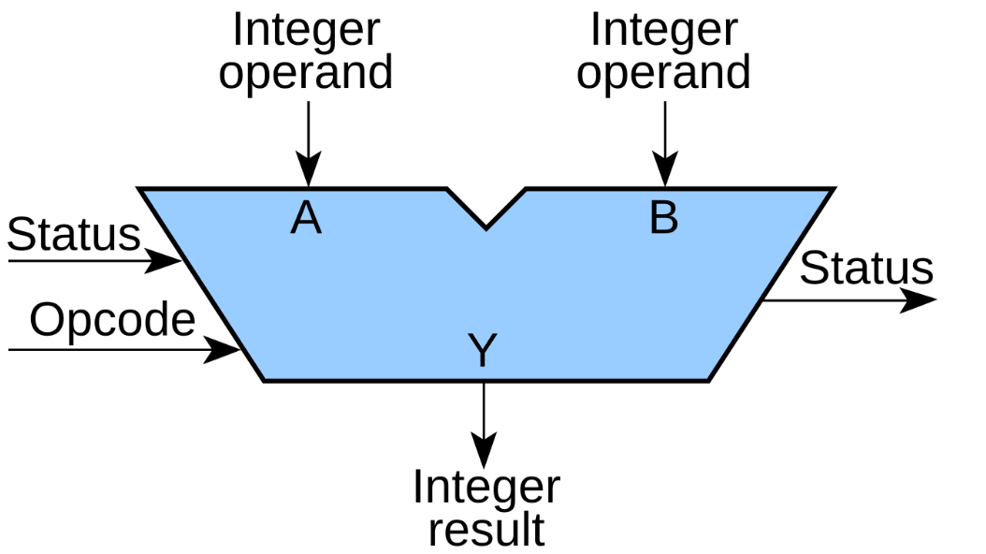
Addition: The ALU computes the sum of A and B using binary addition. If the ALU is limited to a fixed width such as 16 bits, the result is kept within that width, which means any overflow beyond the width is not kept in Y unless separate status flags exist.
Subtraction: The ALU computes A minus B. In most digital designs, subtraction is implemented by reusing the same adder hardware. The ALU forms the two’s complement of B and adds it to A. This approach is efficient because it avoids building a completely separate subtraction circuit.
AND: The ALU performs a bitwise AND operation, meaning it compares each bit position of A with the corresponding bit position of B. The output bit becomes 1 only when both input bits at that position are 1.
OR: The ALU performs a bitwise OR operation. The output bit becomes 1 when either A or B has a 1 at that bit position.
XOR: The ALU performs a bitwise exclusive OR operation. The output bit becomes 1 when A and B are different at that bit position, and becomes 0 when they are the same.
Shift left: The ALU shifts the bits of A to the left by a specified amount, commonly by one bit in simple ALUs. Zeros are inserted into the least significant side. This operation is often used for multiplying by powers of two in unsigned arithmetic.
Shift right: The ALU shifts the bits of A to the right by a specified amount, commonly by one bit. Zeros are inserted into the most significant side in a logical shift. This operation is often used for dividing by powers of two in unsigned arithmetic.
Opcode: An opcode is the control value that tells the ALU which operation to execute. It is a small binary code that acts like a selector.
Inside the ALU, several operation results may be computed or available through different logic paths. The opcode is decoded to select exactly one of those results as the final output Y. In a processor, the opcode often comes from the instruction being executed. In this project, the opcode is simply an input driven by the testbench to choose operations during verification.

Clocked design
A clocked design is a digital system where important signals are stored in registers, and those registers update only at specific moments defined by a clock signal. The clock is a repeating square wave that acts like a metronome. On each active clock edge, the design captures new values into its registers and moves from one stable state to the next.
Between clock edges, the registers hold their values steady. Internal combinational logic may be computing “next values” based on current register contents and current inputs, but the design does not officially change state until the next clock edge arrives and the registers latch the new values.
Why clocked design is used
- It creates predictable timing boundaries, because state changes happen only on clock edges.
- It reduces chaos and makes large designs easier to reason about, because signals are expected to be stable within a clock cycle.
- It enables pipelining, where work is split across cycles and performance can be increased by running the clock faster.
The design looks at inputs and current state during the cycle.
It computes what should happen next.
On the clock edge, it commits those new values into registers.

Reset
Reset is a control signal that forces the design into a known, safe starting condition. Digital systems power up in an unknown state because registers may contain random values at power-on. Reset solves this by clearing or initializing registers so the system begins from a predictable state.
When reset is asserted, the design sets important registers to defined values such as zero, idle, or a known start address. When reset is released, normal operation begins and the design starts updating on clock edges again.
- It prevents undefined behavior at startup.
- It ensures state machines start in the correct initial state.
- It makes simulation and debugging reliable, because the starting conditions are controlled.
- Two common reset styles
Synchronous reset
- The reset is applied only on a clock edge.
- The design reacts to reset at the same time it would normally update.
- This often simplifies timing analysis, because reset behaves like other synchronous signals.
Asynchronous reset
- The reset can force registers immediately, without waiting for a clock edge.
- This is useful for fast initialization and for ensuring the design can be forced into a safe state even if the clock is not running.
- It requires careful handling when releasing reset, because deasserting reset must be done safely to avoid metastability.

How clock and reset work together
A common sequence is:
- Assert reset to force all registers into a known state.
- Run the clock while reset is asserted to guarantee initialization is captured everywhere.
- Deassert reset so the design begins normal, predictable clocked operation.

Waveform
Interpreting a waveform involves examining how signals—such as clock, reset, inputs, and outputs—change over time. It helps you understand how input changes are captured on clock edges and how outputs correspond to earlier inputs based on the design’s timing.

Difference Between Combinational and Registered ALU Outputs

Combinational ALU output
In a combinational ALU, the output is purely a function of the current inputs. As soon as you change A, B, or the opcode, the logic inside the ALU starts resolving to a new result. After a small propagation delay through gates, the output settles to the correct value.
- The ALU output changes whenever any input changes.
- There is no clock involved in producing the output.
- The result is not stored inside the ALU; it is just the immediate logic result.
- If the inputs wiggle or glitch, the output can also momentarily wiggle until it stabilizes.
- In verification, you usually apply inputs, wait a short time for settling, then check the output.
- Inputs change
- A short time later the output settles
- If inputs change again, output changes again
This style is commonly used for simple blocks, learning projects, or as a sub-block inside a larger synchronous design where the output is captured by registers elsewhere.

Registered ALU output
In a registered ALU, the ALU still computes a result from A, B, and the opcode, but the output is not driven directly to the output pin. Instead, the computed result is captured into a register on a clock edge. The visible ALU output only updates at that clock edge.
- The output updates only on the active edge of the clock.
- Between clock edges, the output remains stable, even if the inputs change.
- The result is stored in flip-flops, so it is part of sequential logic.
- Reset typically forces the output register into a known value at startup.
- In verification, you apply inputs before a clock edge, then check the output after the clock edge.
- Inputs and opcode are applied
- At the next clock edge, the ALU captures the computed result
- Output changes only at that clock edge and holds steady until the next edge
This style is common in real processors and pipelined datapaths because it makes timing closure easier, supports high-frequency designs, and creates predictable cycle-by-cycle behavior.

0.2 Verification mindset

Self-Checking Testbench
A self-checking testbench is a verification testbench that determines whether the design is correct without requiring you to manually inspect waveforms or outputs.
In a traditional non-self-checking testbench, you apply inputs to the design, look at the output, and decide by hand whether the output matches what you expected. In a self-checking testbench, that decision is built into the testbench itself.
- The testbench applies a test input to the design under test.
- It also computes or looks up the expected correct output for that same input.
- It compares the expected output with the actual output produced by the design.
- If they match, the testbench records a pass for that test case.
- If they do not match, the testbench records a failure and prints enough details to reproduce and debug the issue, such as the input values, the operation selected, the expected result, and the actual result.

Advantages of Self-Checking Testbench
- You can run thousands of tests automatically and get a clear pass or fail outcome.
- Failures are immediately visible and repeatable, which speeds up debugging.
- The verification flow becomes suitable for regression testing, meaning you can rerun the same tests after making RTL changes to ensure nothing broke.
In short, a self-checking testbench is one that acts like an automated judge: it applies stimulus, checks correctness, and reports pass or fail on its own.

Reference (Golden) Model
A reference model, also called a golden model, is a trusted implementation of what the design is supposed to do. It acts as the “source of truth” for expected behavior during verification.
- It is a simple, correct model of the intended functionality.
- It can be written in a convenient language such as Python, C, or SystemVerilog.
- It is usually easier to read and review than the RTL, and it avoids the same implementation tricks or optimizations used in the hardware.

Advantages
- It tells us the correct expected output for any input
When you run many tests, especially randomized tests, you need a reliable way to know what the output should be for each input and operation. The reference model computes that expected result so the testbench can compare it against the DUT output automatically.
- It enables self-checking automation
A self-checking testbench needs two things: the actual DUT output and the expected output. The reference model produces the expected output, which makes automatic pass or fail decisions possible without manual waveform inspection.
- It prevents “guessing” and reduces human error
Without a golden model, you may end up hardcoding a few expected values or manually checking waveforms. That approach misses many cases and is error-prone. A reference model makes verification consistent and scalable.
- It helps isolate bugs faster
If the DUT output mismatches the reference model, you immediately know there is a functional disagreement. The testbench can print the exact inputs, opcode, expected output, and actual output, making it easier to reproduce and debug.
- It supports regression testing and repeatability
Once the golden model exists, you can keep rerunning the same tests every time the RTL changes. This catches accidental breakages early and builds confidence that the design remains correct over time.
In this ALU project, the Python reference model plays this role by computing the correct result for each combination of inputs and opcode. The SystemVerilog testbench then compares the ALU output against that expected result and reports pass or fail automatically.

Randomized Testing
Randomized testing means the testbench automatically generates many different valid input values and opcodes, instead of only a few hand-written test cases.
- It can find bugs that directed tests miss because:
- Directed tests cover only the cases you think of, so unusual combinations get skipped.
- Random tests explore a much larger input space and naturally hit rare patterns, overflows, underflows, and boundary values.
- With a fixed random seed, any failure can be reproduced and debugged.

Scoreboard
A scoreboard is a checking mechanism in a testbench that keeps track of what outputs are expected and then verifies the design’s real outputs against those expectations.
When the testbench applies an input to the design, it also uses a reference model to calculate the correct result. The scoreboard stores that expected result and waits for the design to produce its output. When the output arrives, the scoreboard compares expected and actual. If they match, it counts it as a pass. If they do not match, it reports a failure and prints useful details like the input values, the selected operation, the expected output, and the actual output.
This is helpful because it makes testing automatic and organized, and it still works even when the design output is delayed by one or more clock cycles.

Coverage
Coverage is a way to measure how much of the design’s behavior and input space your tests actually exercised. It answers the question: did we really test everything important, or did we just run many tests without knowing what we touched?
Hitting all opcodes means your test set includes every supported operation at least once. For your ALU, that means each opcode value was used in simulation so every operation path was exercised and checked.
Hitting corner cases means your tests included important extreme or risky input conditions that commonly expose bugs, not just random “normal” values. For a 16-bit ALU, corner cases typically include values like all zeros, all ones, maximum and minimum patterns, alternating bit patterns, and cases that cause overflow, underflow, or shifting edge behavior. When you “hit” these, it means those special cases were actually applied during simulation and verified, rather than being assumed.

1. Platform Choice
WSL2 Ubuntu + VS Code Remote was chosen because it provides:
- Linux tool reliability
- Easy installation via apt
- Seamless editing through Windows VS Code

2. Environment Setup

2.1 System Configuration
Operating System: Windows with WSL2
Linux Distribution: Ubuntu (via Microsoft Store)
Editor: Visual Studio Code with Remote-WSL
- Go to Start, then search “Turn Windows features on or off”.
- Enable: Windows Subsystem for Linux and Virtual Machine Platform.
Windows Features showing WSL enabled:
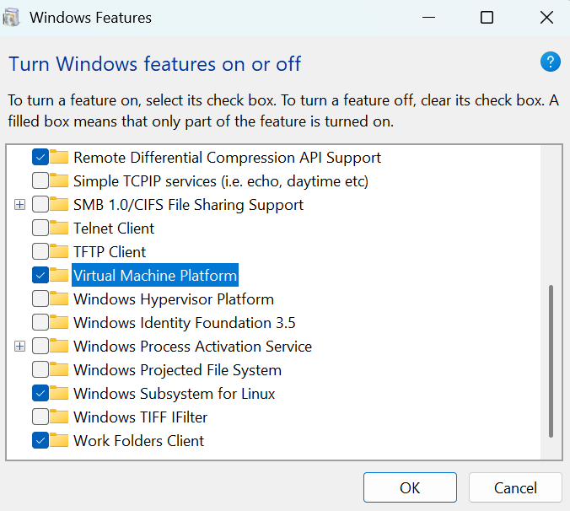
- Restart when prompted.

2.2 Install Ubuntu from Microsoft Store + create Linux username/password
In Microsoft Store search for Ubuntu and Install.
Launch Ubuntu → create a UNIX username and password (this is your Linux login).
This login is only for WSL Ubuntu, not your Windows account.
Username prompt:
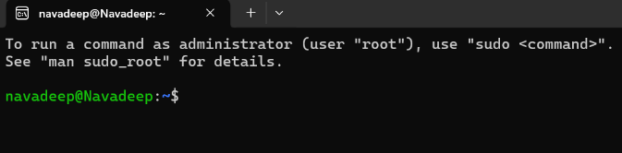

2.3 VS Code Remote - WSL
- Install VS Code on Windows.
- In VS Code go to “Extensions” here install “Remote - WSL”.
- Open Ubuntu terminal → run: .
code .
VS Code showing “WSL: Ubuntu” badge:
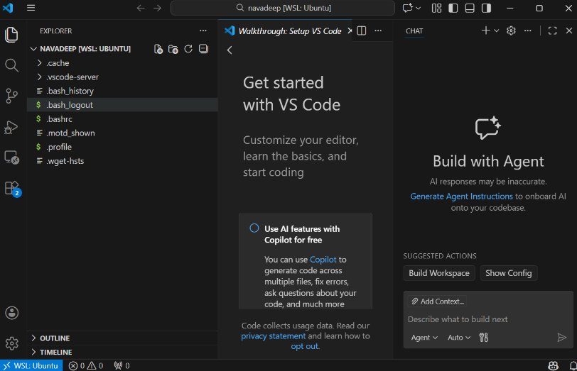

3. Tool Installation
The following tools were installed inside WSL:
- Verilator – RTL simulation
- GTKWave – waveform viewing
- Python 3 – vector generation and golden model
- Make / g++ – build support
Version information was captured for documentation.

3.1 Update packages
Run sudo apt update in linux
Ensures package lists are current.
Successful apt update :
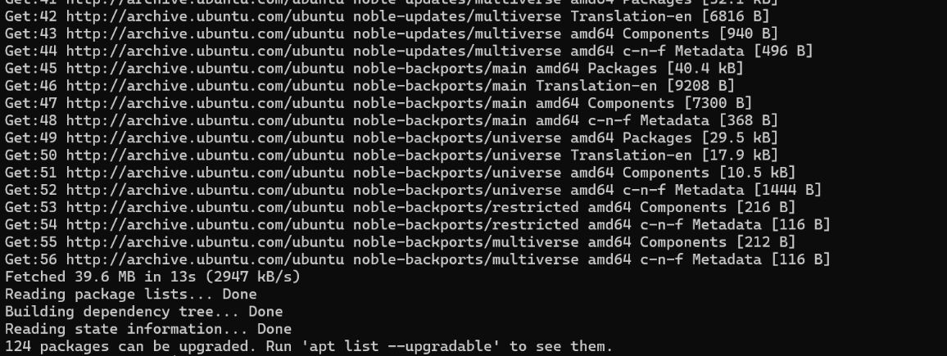
Terminal showing tool versions:
sudo apt install -y verilator gtkwave make g++ python3 python3-pip
verilator --version | tee reports/verilator_version.txt
gtkwave --version | head -n 2 | tee reports/gtkwave_version.txt
python3 --version | tee reports/python_version.txt

3.2 Explanation of choice
Verilator compiles Verilog or SystemVerilog into fast C++ simulation
Verilator does not run your RTL directly like many classic simulators. Instead, it translates your hardware description into equivalent C++ code that behaves the same way as the RTL logic. Then that C++ is compiled into a native executable on your machine. Because the result is compiled machine code, it can run very quickly, which is especially useful when you want to run lots of tests, long simulations, or many random seeds. In practice, this means you can iterate faster, catch bugs earlier, and run regressions without waiting forever.
GTKWave views waveforms such as VCD or FST so beginners can see what happened
When you simulate a design, you can dump signal values over time into a waveform file. VCD and FST are common formats for storing those time based signal transitions. GTKWave is a viewer that opens those files and shows signals on a timeline, so you can literally see when inputs changed, when internal signals responded, and when outputs became valid. This is powerful for debugging because you can trace cause and effect visually, zoom into a specific time window, measure delays in clock cycles, and confirm whether reset, enables, and state transitions happened in the right order.
Python generates random tests and acts as a clean reference model
Python is commonly used to create stimulus because it is quick to write, easy to randomize, and easy to scale into many test cases. Random tests mean you do not only try a few hand picked inputs, you explore many combinations that you might not think of, which often exposes corner case bugs. Acting as a reference model means Python computes the expected output for each test using a simple, trusted implementation of the same functionality. Then your testbench compares the DUT output against the expected value automatically. If there is a mismatch, you get a clear pass or fail signal, and you can save the failing seed or input vector to reproduce and debug the issue.
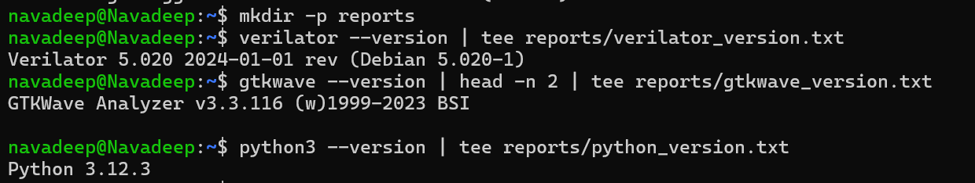

4. Project Workspace
A structured workspace was created to keep RTL, tests, vectors, logs, and documentation separate.
VS Code Explorer showing project tree:
mkdir -p ALU_RandTB/{rtl,tb,py,scripts,build,reports,notes,screenshots,vectors}
cd ALU_RandTB

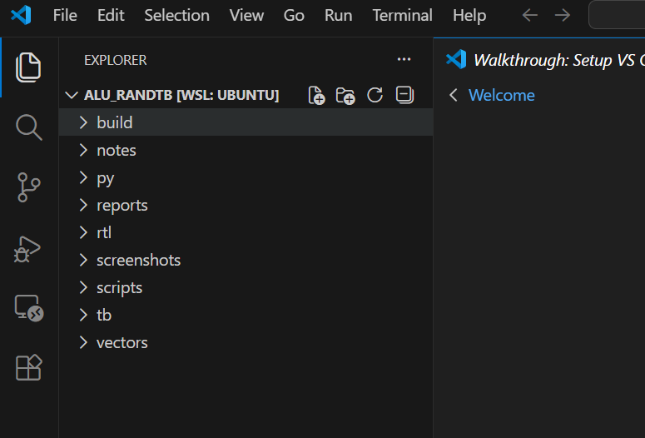

4.1 Create the recording template
The Record Log is a single place where you document everything needed to reproduce your verification results and prove what you tested. Here is what each section contains.
Environment: This section records the exact setup used to run the project. You fill in the versions so anyone can recreate the same toolchain and avoid “version mismatch” problems. It includes the Windows version, the WSL Ubuntu version, VS Code version, and the versions of Verilator, GTKWave, and Python.
Evidence index: This is a checklist of proof files. You list the screenshots you captured and the important output artifacts, such as simulation logs, waveform files, and any generated reports. The goal is to make it easy to find supporting evidence without searching through folders.
Test Runs: This is a structured history of every simulation run you performed. Each row is one run, and it records the design tested, how many test vectors were used, the random seed, which operations were included, whether the run passed or failed, how many mismatches occurred, and any notes. This makes your testing traceable and repeatable.
Bug diary: This is used only if you find bugs. Each entry records what went wrong, how you discovered it, what you changed to fix it, and what proof shows the fix worked. It trains the habit of documenting debugging decisions and provides a clear story of improvement.
Overall, the Record Log turns your project from “I ran it and it passed” into “Here is exactly what I ran, under what conditions, and here is the evidence that it is correct.”
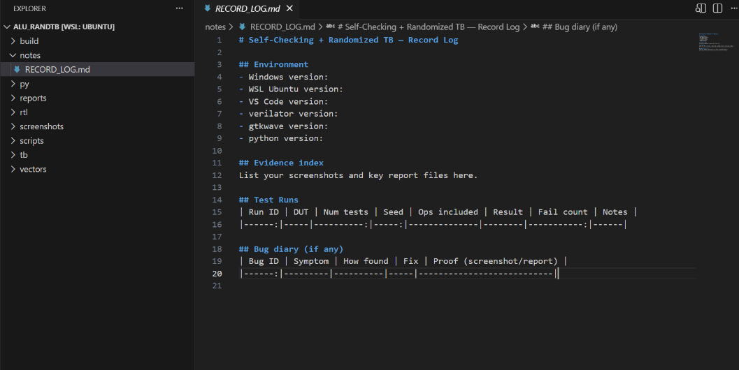

5. Design Under Test (DUT): ALU

5.1 ALU Description
This module implements a parameterized, 16-bit default Arithmetic Logic Unit. It accepts two N-bit inputs and a 3-bit operation selector, and produces an N-bit result. The design is purely combinational, meaning the output depends only on the current values of the inputs and opcode, with no clock or storage elements.
Why this ALU is combinational in this project
A combinational ALU is chosen so verification is easier to understand at a beginner level. Since there is no clocked behavior or pipeline delay, the output settles directly based on the current inputs. This makes expected versus actual comparison straightforward because the testbench does not need to track cycle latency or store expected values for later checking.
How opcode-based control works here
The opcode input selects which operation the ALU performs. Each opcode value maps to exactly one operation. This structure is ideal for learning verification because it is easy to measure whether the test set exercised every operation. A good testbench should ensure every opcode value is applied multiple times with different operand values.
Opcode | Operation
000 | ADD
001 | SUB
010 | AND
011 | OR
100 | XOR
101 | Shift Left by 1
110 | Shift Right by 1
111 | Pass A
Why corner-case vectors matter
In addition to random operand values, certain input patterns are intentionally included because they expose common implementation mistakes:
Zero values confirm the basic identity behavior of operations.
Maximum values and near-maximum values stress overflow and underflow behavior within the fixed bit width.
Alternating patterns such as 1010… and 0101… are excellent for catching bitwise and shift-direction errors, because the output should have a very predictable structure.
Shift operations are especially sensitive to bit-width handling, so patterns with ones near the edges help confirm that zeros are shifted in correctly and no unintended bits leak in.
A combinational design was chosen to keep verification simple and focus on testbench concepts.
ALU source code with opcode table visible:
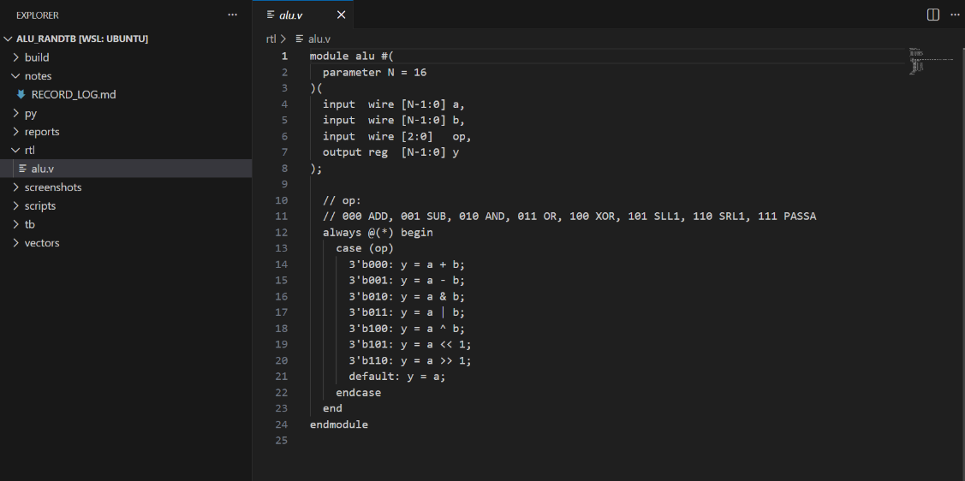

6. Python Golden Model and Vector Generation

6.1 Purpose of Python Model
Python is used as a golden reference model because:
- It is easy to write and review
- It is independent of RTL
- It can generate large randomized test sets quickly

6.2 Randomized Vector Strategy
The vector generator includes:
- Seeded randomness for reproducibility
- Forced corner cases:
  - Zero
  - Maximum value
  - Alternating bit patterns (AAAA, 5555)
- Fully random values afterward
Each vector contains:
a, b, opcode, expected_y

Generate ALU Test Vectors with Python
This step creates a reproducible set of ALU test vectors that will be used by the simulator testbench. The script writes a CSV file containing input operands, the operation code, and the expected output computed by a trusted software reference model. This enables self-checking verification where the DUT output is compared directly against expected results.
The script generates a CSV file at the path given by --out (default vectors/alu_vectors.csv). Each row contains:
a: first ALU operand
b: second ALU operand
op: operation selector (0 to 7)
exp_y: expected ALU output from the Python reference model

Reference model behavior
The function alu_ref(a, b, op, nbits) defines the golden behavior of the ALU. It mirrors fixed-width hardware behavior by applying a bit mask so results wrap around to the selected width. This is important for operations like add and subtract where overflow or underflow must match real RTL behavior.

Reproducibility and debugging
The script uses a user-specified seed (--seed) to control randomness. With the same seed and settings, the generated vectors will be identical every time. This is critical when a failure occurs because you can rerun the exact same stimulus and reproduce the bug consistently.

Corner cases plus random coverage
To improve bug-finding, the generator produces two types of tests:
Forced corner cases: It intentionally tests extreme operand patterns such as 0, 1, all ones, and alternating bit patterns. These commonly expose boundary bugs, masking errors, and bitwise logic mistakes.
Random cases: It then adds a user-defined number of fully random tests. Random combinations help expose unexpected interactions that directed tests may miss.
This combination ensures both guaranteed coverage of known risky inputs and broad exploration of the state space.
Save proof that the golden model is defined and that vectors were generated deterministically:
Keep a screenshot or snippet showing the alu_ref() function definition
Save the terminal output that prints the output file path and seed
Keep the generated CSV file under version control or in an evidence folder for traceability
Python alu_ref() function
cat > py/gen_vectors.py <<'EOF'
import random
import csv
import argparse

def alu_ref(a, b, op, nbits=16):
mask = (1 << nbits) - 1
if op == 0: y = (a + b) & mask
elif op == 1: y = (a - b) & mask
elif op == 2: y = (a & b) & mask
elif op == 3: y = (a | b) & mask
elif op == 4: y = (a ^ b) & mask
elif op == 5: y = (a << 1) & mask
elif op == 6: y = (a >> 1) & mask
else: y = a & mask
return y

def main():
ap = argparse.ArgumentParser()
ap.add_argument("--num", type=int, default=200)
ap.add_argument("--seed", type=int, default=1)
ap.add_argument("--nbits", type=int, default=16)
ap.add_argument("--out", default="vectors/alu_vectors.csv")
args = ap.parse_args()

random.seed(args.seed)

corner = [
0, 1, (1<<args.nbits)-1,
int("AAAA", 16) & ((1<<args.nbits)-1),
int("5555", 16) & ((1<<args.nbits)-1),
]

with open(args.out, "w", newline="") as f:
w = csv.writer(f)
w.writerow(["a","b","op","exp_y"])

# forced corner cases
for op in range(8):
for a in corner:
b = random.choice(corner)
w.writerow([a, b, op, alu_ref(a,b,op,args.nbits)])

# random cases
for _ in range(args.num):
a = random.getrandbits(args.nbits)
b = random.getrandbits(args.nbits)
op = random.randrange(0, 8)
w.writerow([a, b, op, alu_ref(a,b,op,args.nbits)])

print(f"Wrote {args.out} with seed={args.seed}")

if __name__ == "__main__":
main()
EOF
Generating vectors
python3 py/gen_vectors.py --num 200 --seed 7 --nbits 16 --out vectors/alu_vectors.csv | tee reports/gen_vectors.log
head -n 10 vectors/alu_vectors.csv | tee reports/vectors_head.txt
Terminal showing seed:
First lines of CSV file
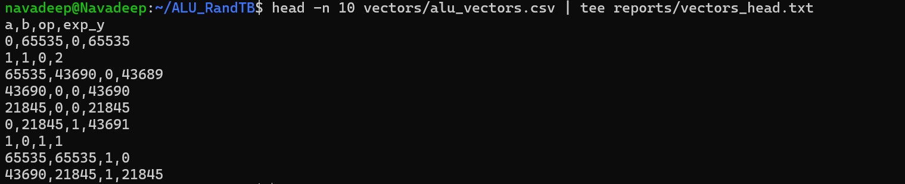

7. Self-Checking Testbench

7.1 Testbench Operation
The SystemVerilog testbench:
- Opens the CSV file
- Reads one vector per iteration
- Drives inputs (a, b, op)
- Waits for signal stabilization
- Compares DUT output to expected value
- Logs failures with full details
This makes the testbench self-checking.
cat > tb/tb_alu_file.sv <<'EOF'
`timescale 1ns/1ps
module tb_alu_file;

localparam int N = 16;

logic [N-1:0] a, b;
logic [2:0] op;
logic [N-1:0] y;

alu #(.N(N)) dut (.a(a), .b(b), .op(op), .y(y));

int f;
int lineno = 0;
int fail = 0;

string line;
int ai, bi, opi, expi;

initial begin
$dumpfile("reports/alu_file_tb.vcd");
$dumpvars(0, tb_alu_file);

f = $fopen("vectors/alu_vectors.csv", "r");
if (f == 0) begin
$display("ERROR: cannot open vectors/alu_vectors.csv");
$finish;
end

// header
void'($fgets(line, f)); lineno++;

while (!$feof(f)) begin
void'($fgets(line, f)); lineno++;
if ($sscanf(line, "%d,%d,%d,%d", ai, bi, opi, expi) == 4) begin
a = ai[N-1:0];
b = bi[N-1:0];
op = opi[2:0];
#1;
if (y !== expi[N-1:0]) begin
$display("FAIL line=%0d a=%0d b=%0d op=%0d exp=%0d got=%0d",
lineno, ai, bi, opi, expi, y);
fail++;
end
end
end

if (fail == 0) $display("PASS: all tests passed");
else $display("FAIL: %0d mismatches", fail);

$fclose(f);
$finish;
end

endmodule
EOF

7.2 Failure Reporting
On failure, the testbench prints:
- CSV line number
- Input values
- Opcode
- Expected output
- Actual output
This allows fast reproduction and debugging.

TB section showing PASS/FAIL print
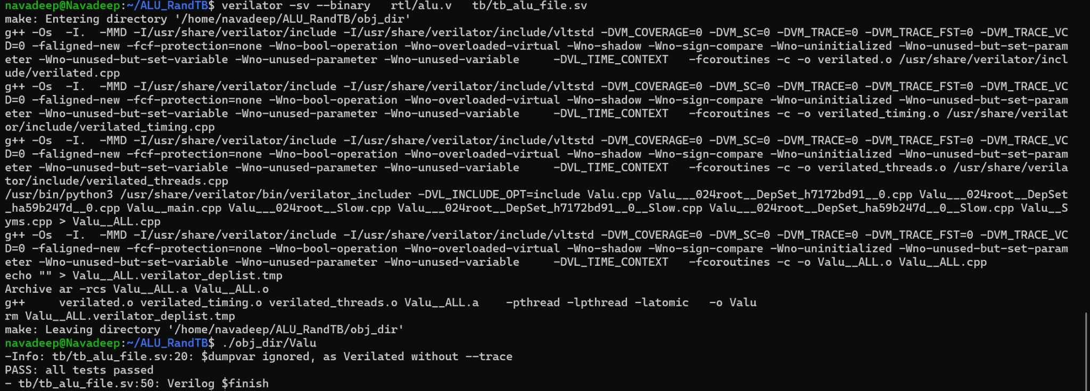
$dumpfile path

8. Simulation with Verilator

8.1 Build and Run Flow
A shell script automates:
- Vector generation (if missing)
- Verilator compilation
- Simulation execution
- Log capture
Simulation output is saved for documentation.
chmod +x scripts/run_verilator.sh
./scripts/run_verilator.sh
screenshot of script
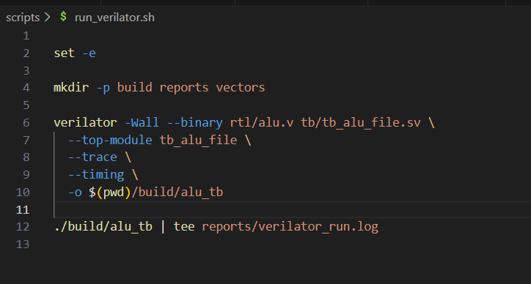
terminal chmod
Terminal showing PASS result:
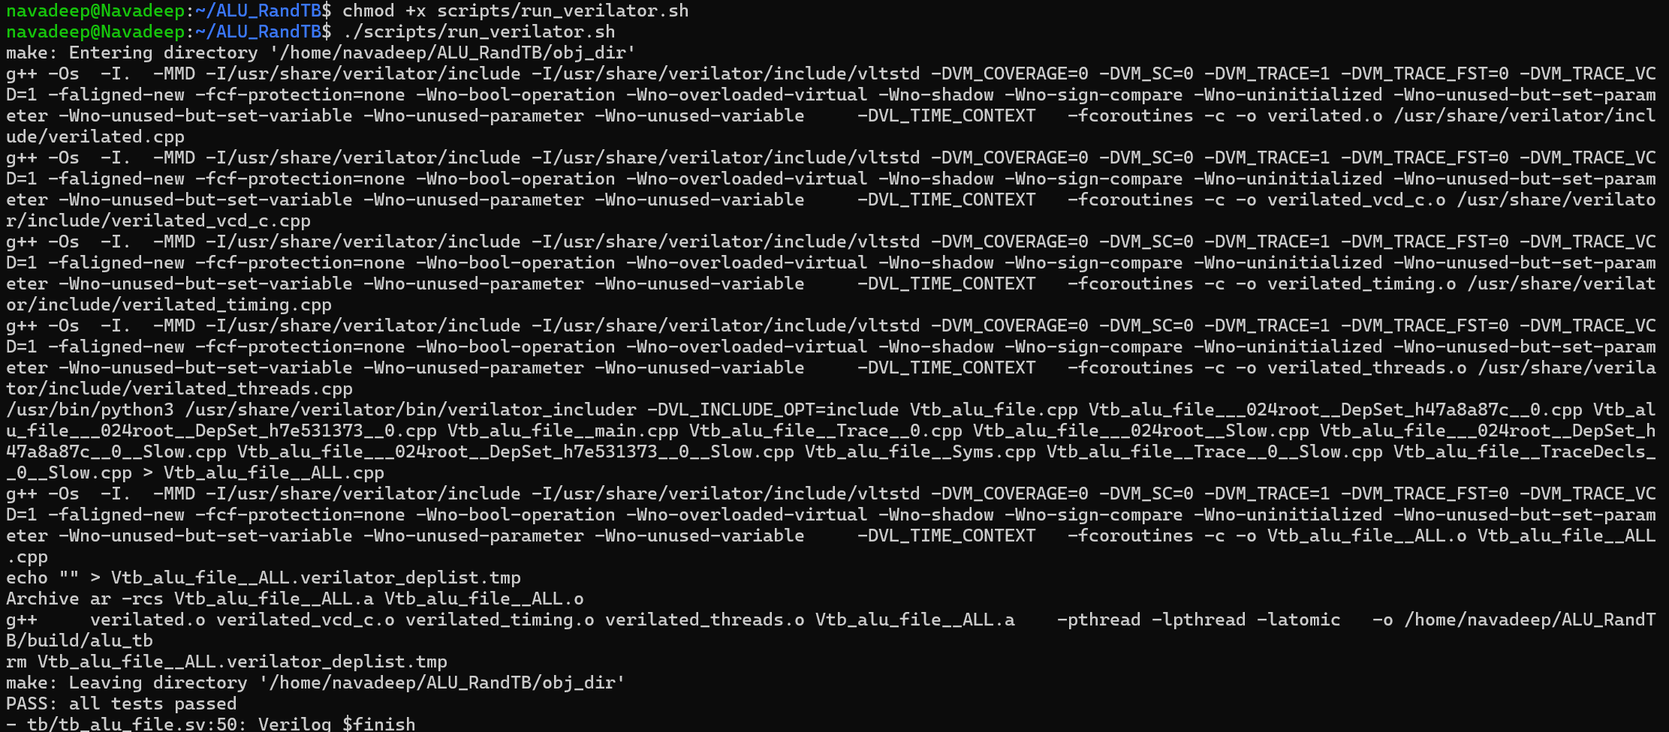

9. Waveform Inspection (GTKWave)

9.1 Purpose of Waveforms
Waveforms allow visual confirmation that:
- Inputs change as expected
- Outputs respond correctly
- Failures (if any) can be located in time
Signals viewed:
- a
- b
- op
- y

9.1 Open the waveform
gtkwave reports/alu_file_tb.vcd
In GTKWave (click-by-click):
- Expand tb_alu_file in left panel.
- Select a, b, op, y → Append to waveform.
- Zoom to see multiple vector applications.
- If failures exist: locate near the failing line number from verilator_run.log and screenshot it.
GTKWave showing signal activity:
